Data collection questionnaire

Table of contents

1. Introduction 4
2. Operational characteristics of the unit 5
3. Generator information 7
4. Alternator external parameter 7
5. Step-up transformer 9
6. Exciter and automatic voltage regulator (AVR) 10
6.1. Over-excitation limiter 11
6.2. Under-excitation limiter 11
6.3. Power system stabiliser (PSS) 11
6.4. In case of brushless exciter 11
6.5. In case of static exciter 12
7. Turbine-governor / prime mover 12
7.1. General Data 12
7.2. Gas turbine 13
7.3. Steam turbine 13
7.4. Combined-cycle 14
8. Wind farm 14
8.1. Wind turbine modelling parameters 14
8.1.1. Induction generator parameters (Fixed-speed, variable-slip, DFIG) 14
8.1.2. Permanent magnet alternator (Full converter) 15
8.1.3. Converter parameters (DFIG, full converter) 15
8.1.4. Pitch and storm mitigation control (if relevant) 15
8.1.5. Aerodynamic 15
8.2. Wind turbine operational characteristics 16
8.3. Wind park 16
8.3.1. Possible compensation means and automatic voltage regulation of the park 17
9. Auxiliaries 17
10. Protections 18
11. Appendix 19
11.1. Appendix 1 19
11.2. Appendix 2 21

Introduction
In the frame of the electrical studies of the Belgian network, the objective of this document is to collect the required data in order to build the model of the production unit allowing static or dynamic simulations. This questionnaire does not replace the other demands of information that the TSO could require within the framework of his activities and in accordance with the grid code.

Operational characteristics of the unit
- Connection node and voltage : ( kV )
- Unit Type : please choose one type of unit in the table below
CL : Classical | D : Diesel | GE : Gas Engine | GT : Gas Turbine
IS : Incineration Station | NU : Nuclear | ST : Steam Turbine | TJ : Turbo Jet
WKK : Cogeneration Unit | WT : Wind Turbine | BG : Biogas | PS : Pomp Station
HU : Hydraulic Unit | CCGT : Combined Cycle | CCGT-ST : Combined Cycle Steam Turbine | CCGT-GT : Combined Cycle Gas Turbine
- Specific average consumption (GJ/MWh) :
Start fuel : please indicate below the fuel type used for machine start
- Start fuel 1 :
- Start fuel 2 (if applicable) :
- Start fuel 3 (if applicable) :

For every type of fuel of the unit, please select the fuel and fill in the related characteristics :
Fuel type 1 :
- Fuel type :
BF : Blast Furnace Gas | CP : Coal pulverized | FA : Fuel A | GO : Gas Oil
LV : LVN | NG : Natural Gas | NU : Nuclear | WA : Water
WI : Wind | WR : Waste Recycle | CP/CG : Mix Coal - Cokes Gas | FA/BF : Mix Fuel A - Blast Furnace
CP/BF : Mix Coal - Blast Furnace | CG : Cokes Gas | CP/ST/BG: mix coal-steam-biogas
- Ramping rate (MW/min) :
- Emergency Ramping Rate (MW/min) :
- Technical Pmin (MW) :
- Technical Pmax (MW) :
Fuel type 2 (if applicable) :
- Fuel type :
BF : Blast Furnace Gas | CP : Coal pulverized | FA : Fuel A | GO : Gas Oil
LV : LVN | NG : Natural Gas | NU : Nuclear | WA : Water
WI : Wind | WR : Waste Recycle | CP/CG : Mix Coal - Cokes Gas | FA/BF : Mix Fuel A - Blast Furnace
CP/BF : Mix Coal - Blast Furnace | CG : Cokes Gas | CP/ST/BG: mix coal-steam-biogas
- Ramping rate (MW/min) :
- Emergency Ramping Rate (MW/min) :
- Technical Pmin (MW) :
- Technical Pmax (MW) :

Fuel type 3 (if applicable) :
- Fuel type :
BF : Blast Furnace Gas | CP : Coal pulverized | FA : Fuel A | GO : Gas Oil
LV : LVN | NG : Natural Gas | NU : Nuclear | WA : Water
WI : Wind | WR : Waste Recycle | CP/CG : Mix Coal - Cokes Gas | FA/BF : Mix Fuel A - Blast Furnace
CP/BF : Mix Coal - Blast Furnace | CG : Cokes Gas | CP/ST/BG: mix coal-steam-biogas
- Ramping rate (MW/min) :
- Emergency Ramping Rate (MW/min) :
- Technical Pmin (MW) :
- Technical Pmax (MW) :

Generator information
Manufacturer :
Type :
Year manufactured :
Snom Rated apparent power (+ related ambient temperature) MVA
Pnom Rated active power (+ related ambient temperature) MW
Unom Rated terminal voltage kV
ΔU₊ Tolerance on the terminal voltage above the rated voltage %
ΔU₋ Tolerance on the terminal voltage under the rated voltage %
Inom Rated stator current at standard cooling condition kA
Cos  Rated power factor
ωnom Rated speed rpm
PD²alt Moment of inertia (generator + excitator) ton x m2

- Generator capability curves (An example is given in appendix 1).

- Please attach the saturation curves (An example is given in appendix 1).

- Diagram or tabular showing the evolution of the maximal active and apparent power (Pmax and Smax) versus the cooling system (water temperature, ambient temperature and/or hydrogen pressure)

Alternator external parameter
Remark : generally the manufacturer provides the alternator parameters in per unit base Snom (apparent rated power in MVA). It is important to specify the value of Snom. If the data are also provided in Ohm, please indicate them.

SN Reference value used for per unit calculation MVA
Ra Stator resistance pu
Ta Stator time constant s
Xl Stator leakage reactance pu
Xd Direct-axis unsaturated reactance pu
X'd Direct-axis unsaturated transient reactance pu
X"d Direct-axis unsaturated sub-transient reactance pu
Xq Quadrature-axis unsaturated reactance pu
X'q Quadrature-axis unsaturated transient reactance pu
X"q Quadrature-axis unsaturated sub-transient reactance pu
T'd0 Direct-axis transient open circuit time constant s
T"d0 Direct-axis sub-transient open circuit time constant s
T'q0 Quadrature-axis transient open circuit time constant s
T"q0 Quadrature-axis sub-transient open circuit time constant s
H Inertia (all rotating mass) s
X0 Unsaturated zero sequence reactance pu
X2 Unsaturated negative sequence reactance pu
R0 Zero sequence resistance pu
R2 Negative sequence resistance pu

Step-up transformer
Snom Apparent nominal power MVA
Unom1 Machine-side nominal voltage kV
Unom2 Network-side nominal voltage kV
Xcc Short circuit reactance Ucc%
PCu Copper losses kW
PFe Iron losses kW
Im Magnetising current A

- Connection and earthing of the transformer windings (ex Yd11)
- Possible ground connection impedance (at primary and/or secondary winding)?
- Connection of an auxiliary tertiary winding in delta?
- Shell or Core type transformer?
- Free or forced fluxes magnetic path?
- Xcc13 et Xcc23 : Short circuit reactance primary-tertiary and secondary-tertiary
- PCu13 et PCu23 : Copper losses primary-tertiary and secondary-tertiary

- If the magnetic path is forced (three-legged core type transformer):

Xcc0 Zero sequence short circuit reactance Ucc%
PCu0 Zero sequence copper losses kW
PFe0 Zero sequence iron losses kW
Im0 Zero sequence magnetising current A

- Moreover, in case of tertiary winding :

Xcc013 et Xcc023 : Zero sequence short circuit reactance primary-tertiary and secondary-tertiary
PCu013 et PCu023 : Zero sequence copper losses primary-tertiary and secondary-tertiary
- Is the transformer equipped with a tap changer? If yes, please provide the following data:
- Regulated side (machine or network)
- Number of taps and voltage variation per tap (in kV or in %)
- Under load tap changer?
- Present tap setting
- Is it equipped with an automatic tap controller (for example, automatic tap modification to keep a constant voltage) ? If yes :
- regulating voltage range
- dead band
- delay in second between 2 tap changes

- Magnetic saturation curve
- For the wind farm, please indicate the data regarding the step-up transformer to the network and the data regarding the LV-MV transformer associated to each turbine (indicate if there is different types)

Exciter and automatic voltage regulator (AVR)
Excitation system used (static exciter, rotating AC alternator exciter,…):
Manufacturer :
Type :
Ir_nom Rated exciter current A
Ur_nom Rated exciter output voltage V
Ur_max Maximum permanent exciter output voltage V
Ur_min Minimum permanent exciter output voltage V
Ir_ceil Maximum exciter current (ceiling value) A
Ur_ceil Maximum exciter output voltage (ceiling value) V
Regulating range (automatic loop) %Un
Reactive current voltage sensitivity range (droop) ± % d(U/Unom)/d(Iq/Inom)
Actual reactive current voltage sensitivity %
- For U = Unom and P = Pnom, what is the maximum reactive power, the ceiling value (QMAXPNOM) that enables the over-excitation limiter that brings back the reactive production to a fold-back value and this fold-back value (QMAXlim)?
- Is the regulator equipped with an adjustment loop of reactive production and/or power factor? What is the time constant of this loop?
- Does the voltage regulation use a stator current limitation? If yes :
- Activation threshold
- Activation delay in second

- Block diagram of the excitation system with the feedback loops and the associated limiters, with the value of the different parameters (an example of such a diagram block is given in appendix 2).

- Available tests reports of the voltage regulator.

Over-excitation limiter
- Is the machine equipped with an over-excitation limiter?
- What is the activation threshold (% rated exciter output voltage)?
- What is the activation delay? (if the delay depends on the over shoot, please attach a plot of the evolution or the pair value (%Ur_nom, temporisation) )
- What is the over-excitation reset criterion?
- Please depict on the capability curves of the alternator, the limiter characteristic in the P (active production) – Q (reactive production) plane.

Under-excitation limiter
- Is the machine equipped with an under-excitation limiter?
- What is the activation threshold (% rated exciter output voltage)?
- What is the activation delay?
- What is the under-excitation reset criteria?
- Please depict on the capability curves of the alternator, the limiter characteristic in the P (active production) – Q (reactive production) plane.

Power system stabiliser (PSS)
- Is the unit equipped with a PSS? if Yes
- Is it activated ?
- What is (are) the input(s) of the PSS?
- Block diagram of the regulating loop of the PSS and the values of the time constants and the gain (An example is given in appendix 2).
- Available tests report of the PSS and the possible modification of the parameters.

In case of brushless exciter
- Stator voltage output of the main alternator
- Excitation current of the main alternator
- Excitation voltage of the main alternator
- Output voltage (before rectification by the bridge) of the brushless
- Excitation current of the brushless
- Excitation voltage of the brushless

For the following operating points of the main alternator :
- at no load
- at nominal power

Every limitation must be mentioned (either due to the thyristors controlling the brushless or due to the diode bridge of the brushless, or others).
Tables or graphical representations linking the above required data by pairs are accepted.

In case of static exciter
Data regarding the exciter transformer:
Snom Rated apparent power MVA
U1 alternator-side rated voltage kV
U2 Network-side rated voltage kV
Xcc Short-circuit reactance Ucc%

- Other comments regarding the automatic voltage regulation:
…

Turbine-governor / prime mover

General Data
Manufacturer :
Type :
Energy source :
Pmax Maximum active power output MW
Pmin Minimum active power output MW
Pnom Rated active power (related ambient temperature) MW
PD²turb Turbine moment of inertia ton x m²
PD²tot Global unit moment of inertia (alternator + turbine + gear box) ton x m²
- If available, the torsionnal analysis of the global shaft
- If the unit is equipped with a speed governor control:
Droop setting:
Dead band:
Power range for the speed control:

- Block diagram (transfer functions and non-linearities) of the turbine (or prime mover), the valves (or gates), the speed governor system, the different feedback loops and the limiters, with the related numerical data.

- Any time constants you have from the manufacturer describing the speed response of the governor. Be sure to identify each time constant (combustion, steam drum,…).
For gas turbines, steam turbines, combined cycles and wind farms, specific informations are required. Please provide them by filling the appropriate section hereunder

Gas turbine
- Description of the different regulators et limiters :
- Temperature limiters at the turbine access
- IGV control and influence on the air flow
- Fuel flow regulation
- Limitation of the flame temperature, compressor surging, acceleration limiter, etc.…

- Documents showing the performance characteristics of the gas turbine. For different ambient temperatures and for different load factors:
- the electrical power at the alternator output terminal
- the fuel flow
- the turbine output temperature
- the exhaust flow

Steam turbine
- Block diagram of the steam turbine with the control laws and the limiters.

- Interaction type between the turbine and the boiler (turbine follow mode, boiler follow mode,…)

- Block diagram of the boiler and its parameters (pressure control, temperature limiter, time constants,…) or if these data are not available, technical information necessary for their calculation (volume, limiters,…).

- Does the turbine system have a reheat process (i.e., both high- and low-pressure turbine) ?
- For a steam turbine, indicate the percent of full load power produced by each turbine :
LP turbine : %
MP turbine: %
HP turbine: %
- Does the steam turbine have a fast valving system? If yes :
- activation criteria
- valves closing speed

- Other comments regarding the speed regulator/ prime mover governor :
…

Combined-cycle
- Fill in the part 7.2 and 7.3 concerning the gas turbine, the steam turbine, and the waste heat boiler
- Indicate the percent of full load power produced by each component:
Gas turbine : %
Steam turbine : %

Wind farm

Wind turbine modelling parameters
Basic wind turbine generator parameters should be provided as following:
- Manufacturer, model and type ( precise the number of each type if different manufacturers or models)
- Rated power of each type of turbine
- Power calculation from wind speed
- Hub high
- Number of blades
- Rotor diameter
- Cut-in, Cut-out and rated wind speed

Induction generator parameters (Fixed-speed, variable-slip, DFIG)
Rs stator resistance Ω
Rr rotor resistance Ω
Xs stator reactance Ω
Xr rotor reactance Ω
Xm rotor-stator mutual reactance Ω
H inertia s

Permanent magnet alternator (Full converter)
Refer to §3 and §4.

Converter parameters (DFIG, full converter)
- Buck and boost, rectifier model
- Inverter model
- Filters

Pitch and storm mitigation control (if relevant)
- Block diagram of the stall/pitch control with the parameter values
- Storm mitigation pitch control blocs and parameters
Betamin minimum pitch angle deg
Betamax maximum pitch angle deg
Vcbeta maximal speed variation of the pitch (increasing) deg/s
Vdbeta maximal speed variation of the pitch (decreasing) deg/s

Aerodynamic
Aerodynamic and mechanical drivetrain models along with characteristic curves of the electrical power versus the wind speed, the rotor speed versus the wind speed and the pitch angle versus the wind speed.
Nmin minimum rotor speed rpm
Nmax maximum rotor speed rpm
Vmin wind cut in speed m/s
Vmax wind cut off speed m/s
Vrtd wind speed when P = Pmax and pitch angle = 0 m/s
Rpal blades radius m
Tbase rated torque on the low-speed shaft side N m
Mred gearbox ratio

Wind turbine operational characteristics

Control and network interactions
- Behaviour in case of short-circuit
- Behaviour in case of abrupt change of short circuit power at the point of common connection.
- Overall wind behaviour in case of sustained high speed profile
- Disconnection criteria + corresponding delay and disconnection time
- Reconnection criteria + corresponding delay and reconnection time
- Maximum power injected or absorbed from the network by the grid side converted
- Capability curves of a wind turbine (of each type) (P-Q curves).
If present, describe the compensation means associated with each turbine.
- Available tests reports (certified wind curve, power quality certificate, wind statistic,…)
- Is the wind turbine equipped with a Star/delta configuration switch?
If yes, criterion to switch from a configuration to the other

Ancillary services
- Fault ride through capability (curve)
- Low voltage support (Reactive current voltage sensitivity (droop))
- Active power control (Active power frequency sensitivity)

Wind park
- Number of wind turbines and their GPS position
- Power curve of each type of turbine (if different)
- Single-line diagram of the wind farm
  - Characteristics of the cables (type, length) and transformers
  - Compensation means and characteristics
  - The data related to the transformer associated to each wind turbine have to be given coherently with section 5
  - Filters (if existing) and characteristics

- Capability curves of the whole wind farm (P-Q curves) for at least the following voltages (0.9pu, 1 pu and 1.1pu) at the point of common coupling. The capability curves should include possible other limitations (e.g. temperature...)
- Characteristic curve of the power delivered by the wind park versus the wind speed
- Equivalent dynamical model for transient RMS simulation at the point of common coupling. The model should reflect at least the behaviours tested during the conformity study and represent the behaviour “as built”.

Possible compensation means and automatic voltage regulation of the park
Capacitor bank (power, number of steps, settings of the voltage control)
Harmonic filter (resonant frequency, type)
Static compensator (power, type)
Description, logic and settings of the Automatic Voltage Control of the wind park
Other comments regarding the compensation means:

Auxiliaries
Type :
Paux Maximum active power consumed by the auxiliaries MW/kW
Qaux Maximum reactive power consumed by the auxiliaries MVAr/kVAR

- Specific protections of the auxiliaries (especially voltage and frequency) :
- Type
- Available settings
- Present settings
- Please attach the curves showing the variation of the auxiliaries consumption versus the output power of the generator. If they are not available, provide the consumption for a zero-, minimum-, rated- and maximum generator output power.
- If the auxiliaries are fed through a transformer, please provide also the data requested for the step up transformer at point 4.
- Backup power in case of not-energized point of common coupling
- Other comments regarding the auxiliaries:
…

Protections
Characteristics of the generator and park protections:
- Frequency relay (under and over frequency)
- Over- and under-voltage protection
- Stator thermal protection / over current protection
- Reverse power relay
- Loss of synchronism protection
- Volts/Hz protection
- Current unbalance (negative sequence) protection
- Stator winding ground fault protection
- Internal park protections philosophy (e.g. differential...)
- Other protections...

Appendix

Appendix 1
Saturation curves example:

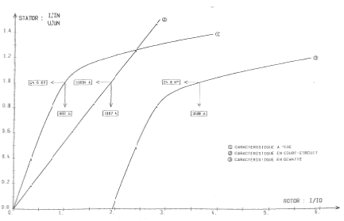

Saturation curves example:

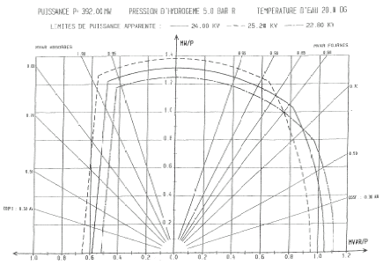

Appendix 2
AVR and PSS block diagram example:
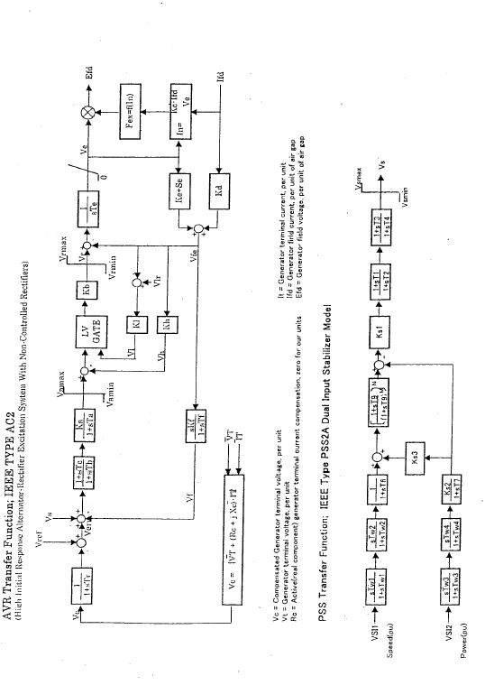

The model should have characteristics in line with the standard IEC 61400-27.

